ATM 348 Mid-Term Test

3/15/2001

- 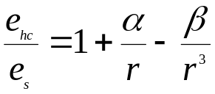The equalibrium saturation vapor pressure e_{hc} over a CCN of radius r can be expressed as
where e_{s} is the saturation vapor pressure over flat water.

- write down the expressions for α and β (10 points).
- describe the physical meanings of all variables in the expressions of α and β (15 points).
- Assume α=1.19x10⁻³ μm, β=0.5x10⁻¹ μm³. If the environment relative humidity is 99%, calculate whether a particle of radius r=1.5 μm will grow or evaporate in this environment (15 points).
- (20 extra bonus points)* Calculate whether this particle will be nucleated in this environment.

- 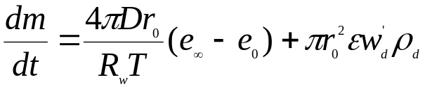The growth of a cloud particle can be described by the following equation:

explain the physical meanings of each term in this equation, and each variable in this equation (30 points).

- Given initial ion number density n=500 cm⁻³, the collision destruction coefficients of α and β as α =1.6x10⁻⁶ cm³ s⁻¹ and β=3x10⁻⁶ cm³ s⁻¹, and aerosol number density N=400 cm⁻³
- calculate the ion destruction rate by collisions among ions themselves (10 points).
- calculate the ion destruction rate by collisions between ions and aerosols (10 points).
- If the production rate of ion by cosmic ray is 2.0 cm⁻³ s⁻¹, will the initial ion density increase or decrease with time (10 points). ?

